### ****Project Title:****

**Laptop Request Catalog Item**

### ****Project Description:****

The **Laptop Request Catalog Item** project aims to streamline and automate the process of requesting laptops for employees through the organization’s service portal. This catalog item allows users to easily select, request, and track the provisioning of laptops based on their role, department, or business requirements.

The solution ensures transparency, reduces manual intervention, and enhances user experience by providing predefined laptop configurations, approval workflows, and integration with asset management systems.

### ****Objectives:****

Simplify the laptop request and fulfillment process.

Ensure standardized laptop models and configurations.

Automate approval workflows based on role, cost, or department.

Improve tracking and reporting of laptop requests.

Integrate with the organization’s **IT Asset Management (ITAM)** and **Configuration Management Database (CMDB)** systems.

### ****Key Features:****

**User-Friendly Interface:** Employees can submit requests via the service catalog portal.

**Dynamic Form Fields:** Automatically display available models or configurations based on user profile.

**Automated Approvals:** Manager or department head approval triggered automatically.

**Real-Time Status Tracking:** Users can view request and fulfillment status.

**Email Notifications:** Automated emails at key workflow stages (submission, approval, fulfillment).

**Integration with Inventory & Asset Management:** Ensures assets are allocated and recorded properly.

### ****Scope:****

Creation of the catalog item form with dynamic laptop options.

Implementation of approval workflows.

Integration with asset management and procurement systems.

Testing and deployment on the Service Portal.

Documentation and user training.

### ****Expected Outcome:****

A fully functional, automated, and user-friendly laptop request system that reduces processing time, ensures standardization, and provides complete visibility into laptop allocation and lifecycle management.

## 🧩 ****State Flow Diagram: Laptop Request Catalog Item****

### ****Textual Representation (you can draw this in Lucidchart, Draw.io, or ServiceNow documentation):****

[Start]

│

▼[Request Submitted]

│

▼[Manager Approval Pending]

│

┌─Yes──────────────┐

│ ▼

│ [Approved by Manager]

│ │

│ ▼

│ [Procurement Processing]

│ │

│ ▼

│ [Asset Allocation / Laptop Assigned]

│ │

│ ▼

│ [Fulfillment Complete]

│ │

│ ▼

│ [Closed]

│

└──No────────────► [Request Rejected]

│

▼

[Closed]

## ⚙️ ****State Descriptions****

| **State** | **Description** |
| --- | --- |
| **Start** | The process begins when a user opens the laptop request catalog item in the service portal. |
| **Request Submitted** | User fills out the catalog form (model, justification, urgency) and submits the request. A new record is created in the system. |
| **Manager Approval Pending** | The request is routed to the user’s manager or department head for approval. |
| **Approved by Manager** | Manager approves the request; workflow transitions to the procurement or IT fulfillment team. |
| **Request Rejected** | Manager rejects the request with comments. The workflow moves to “Closed.” |
| **Procurement Processing** | The procurement/IT team verifies laptop availability or places a new order. |
| **Asset Allocation / Laptop Assigned** | The laptop is assigned to the requester and recorded in the IT Asset Management system. |
| **Fulfillment Complete** | The request has been fulfilled, and confirmation is sent to the user. |
| **Closed** | The request is marked complete (whether approved or rejected), and no further action is required. |

# Code:

import streamlit as st

import pandas as pd

# Initialize session state for requests

if "requests" not in st.session_state:

st.session_state.requests = []

st.title("💻 Laptop Request Catalog Item")

# --- Step 1: Request Submission Form ---

st.header("📝 Submit Laptop Request")

with st.form("request_form"):

name = st.text_input("Employee Name")

department = st.selectbox("Department", ["IT", "HR", "Finance", "Sales", "Operations"])

laptop_model = st.selectbox("Select Laptop Model", [

"Dell Latitude 5440",

"HP EliteBook 840",

"Lenovo ThinkPad X1 Carbon"

])

justification = st.text_area("Justification for Request")

submitted = st.form_submit_button("Submit Request")

if submitted:

new_request = {

"Employee": name,

"Department": department,

"Laptop Model": laptop_model,

"Justification": justification,

"State": "Manager Approval Pending"

}

st.session_state.requests.append(new_request)

st.success(f"Request submitted successfully for {laptop_model}!")

# --- Step 2: Manager Approval Section ---

st.header("🧾 Manager Approval Section")

if len(st.session_state.requests) > 0:

df = pd.DataFrame(st.session_state.requests)

st.dataframe(df)

index = st.number_input("Enter Request Index to Approve/Reject", min_value=0, max_value=len(st.session_state.requests)-1, step=1)

action = st.radio("Action", ["Approve", "Reject"])

if st.button("Submit Decision"):

if action == "Approve":

st.session_state.requests[index]["State"] = "Approved by Manager"

st.success("✅ Request Approved.")

else:

st.session_state.requests[index]["State"] = "Request Rejected"

st.error("❌ Request Rejected.")

else:

st.info("No requests submitted yet.")

# --- Step 3: Fulfillment Section ---

st.header("🚚 Fulfillment Processing")

approved_requests = [r for r in st.session_state.requests if r["State"] == "Approved by Manager"]

if approved_requests:

selected = st.selectbox("Select Approved Request for Fulfillment", [r["Employee"] for r in approved_requests])

if st.button("Mark as Fulfilled"):

for req in st.session_state.requests:

if req["Employee"] == selected:

req["State"] = "Fulfillment Complete"

st.success(f"Laptop request for {selected} marked as fulfilled.")

else:

st.info("No approved requests ready for fulfillment.")

# --- Step 4: Final View ---

st.header("📊 Current Request Status")

st.dataframe(pd.DataFrame(st.session_state.requests))

# Screenshots:

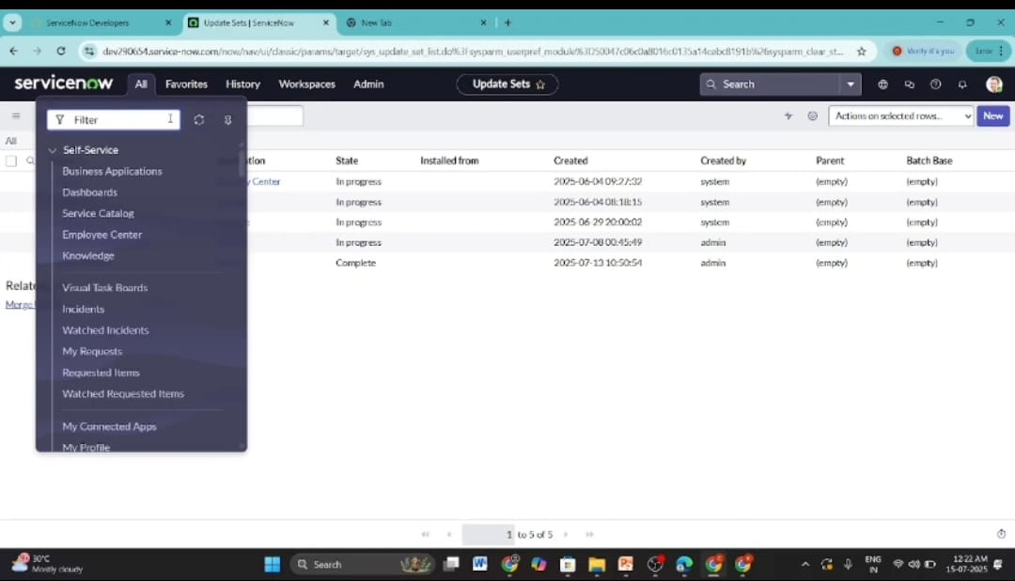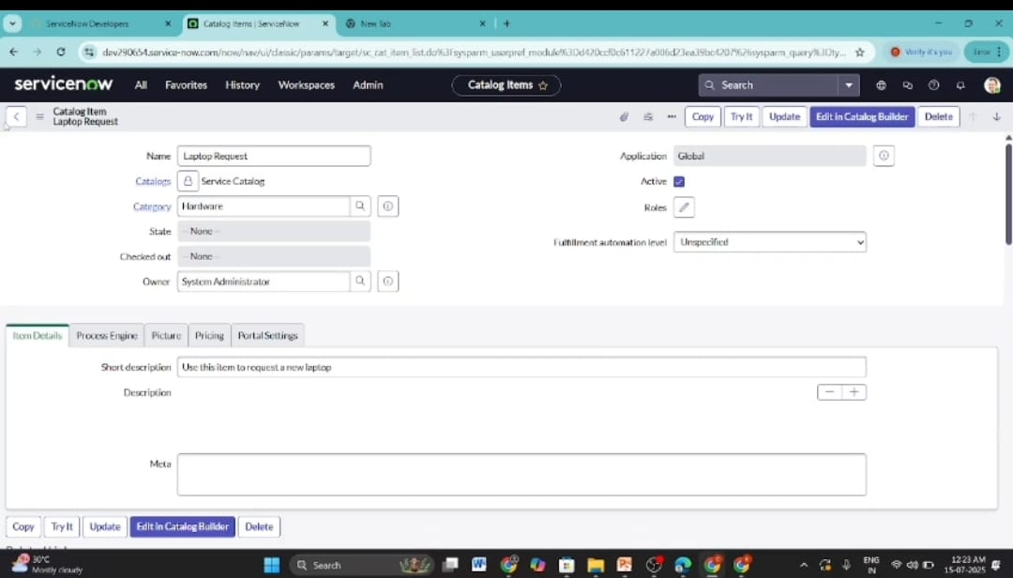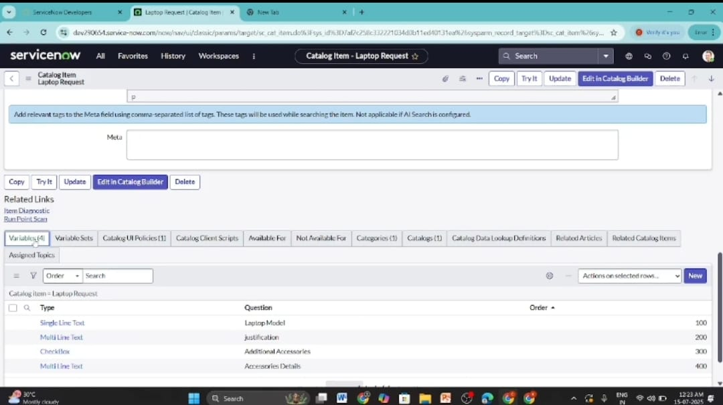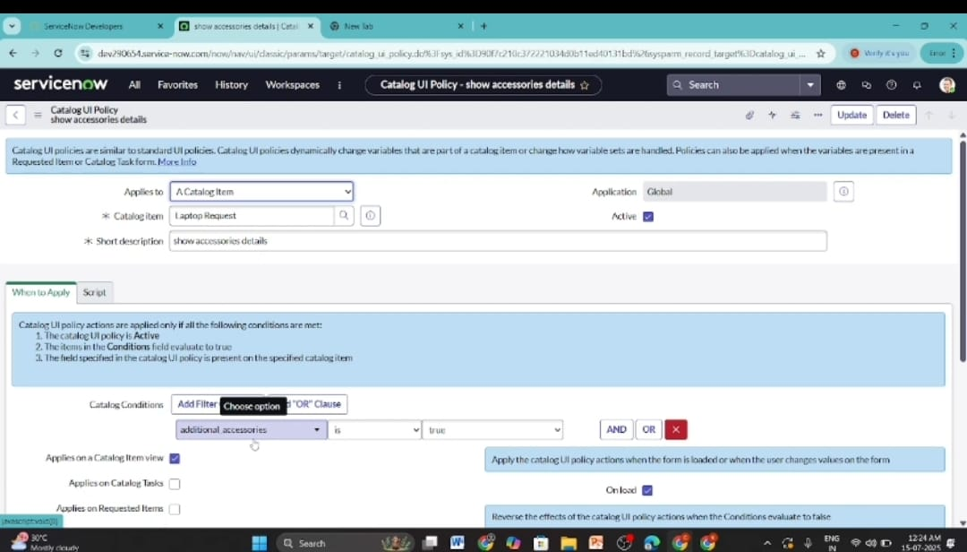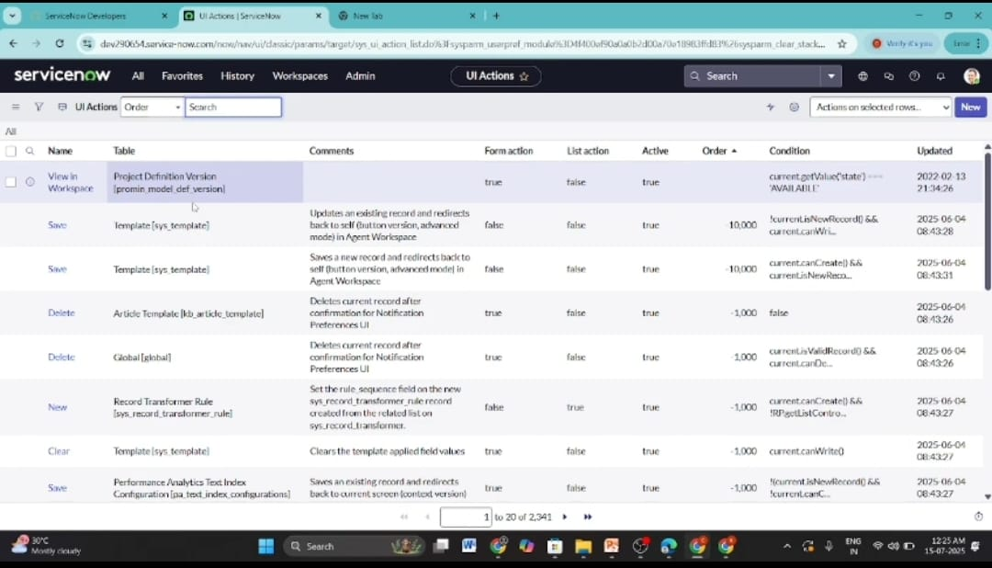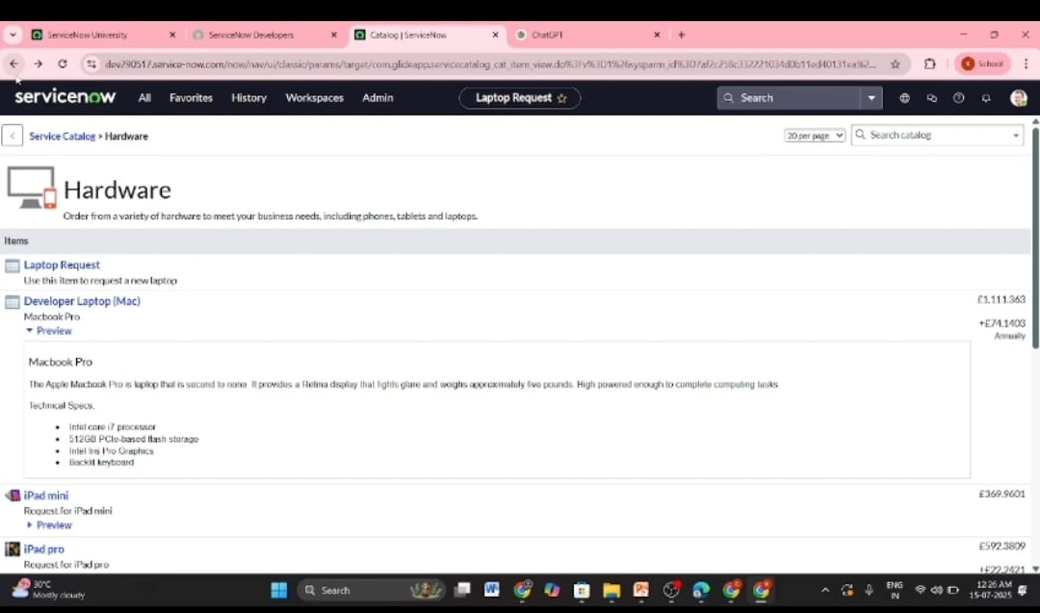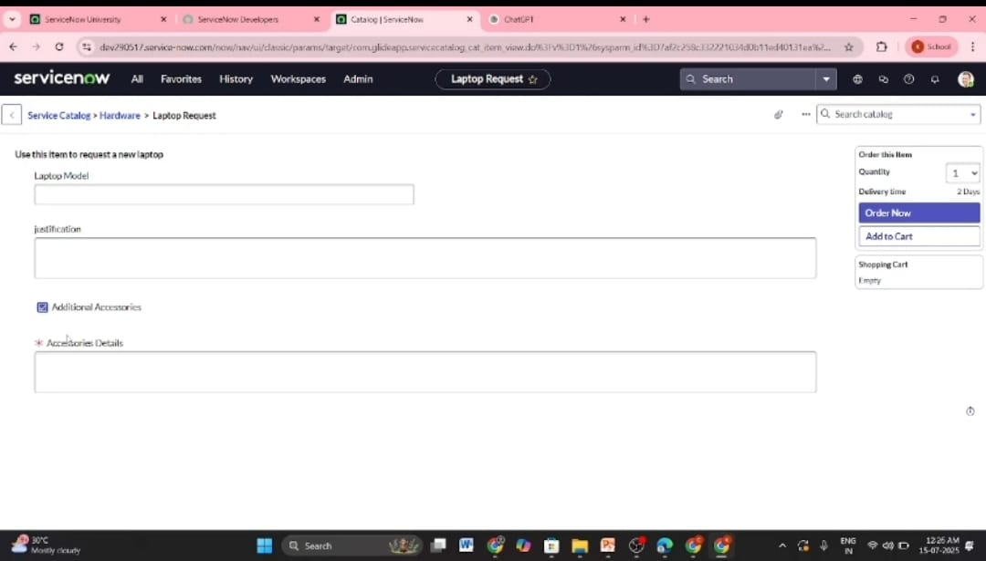

## ****Conclusion****

The **Laptop Request Catalog Item** project successfully simplifies and automates the laptop request and approval process within an organization. By providing a centralized and user-friendly portal, employees can easily submit laptop requests, managers can efficiently approve or reject them, and the IT or procurement team can manage fulfillment and asset allocation with transparency.

This solution reduces manual paperwork, minimizes delays, and ensures accountability through automated state transitions and status tracking. The workflow enhances operational efficiency, ensures standardization in laptop allocation, and integrates seamlessly with IT asset management processes.

Overall, the project achieves its goal of **streamlining the laptop provisioning process**, **improving communication between departments**, and **enhancing employee satisfaction** through faster and more transparent service delivery.